Hand In #2 : Proportions & Unit Rates
Miss McKechnie

1. A 13-year-old’s heart might beat about 90 times per minute. About how long would it take her heart to beat 5000 times?

2. A school district report says its student-to-teacher ratio is 25:1. The district has 55 teachers and 1460 pupils. Is the report accurate? Solve and explain.

3. The price of raisins a bulk food store are shown in the table below:

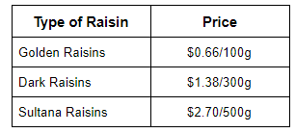
a. Which type of raisin is the cheapest?

b . What is the difference in price between the cheapest and most expensive raisin type per 100 g?

4. Trevor drove his car 120 km in 3h. Jillian drove her car 110 km in 2.5 h. Who drove more kilometers per hour. Solve and explain.

5. There are 48 passengers on a bus. At the first stop 16 passengers got off and 12 passengers got on the bus. What is the ratio of passengers who got on to passengers who got off the bus?

6. Last night 30 cm of snow fell in 6 hours. If it continues snowing at the same rate, how long will it take for 45 cm to fall?

