Measurement Hand-In #1
Miss McKechnie

- Calculate the surface area of each of the following shapes (remember units² and show all your work)

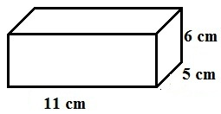

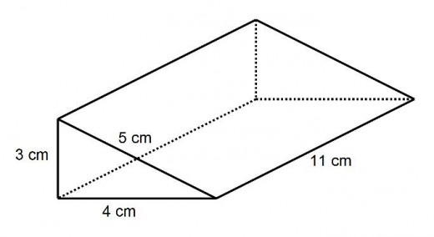

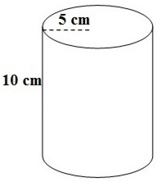

- Calculate the surface area of the triangular prism below;

- A cosmetics company that makes small cylindrical bars of soap wraps the bars in plastic prior to shipping. Find the surface area of a bar of soap if the diameter is 5 cm and the height is 2 cm. Use 3.14 for π.

- Mrs. Keith is wrapping a present for her husband. She has enough wrapping paper to cover a surface area of 456cm². What are the largest dimensions her present could be? Draw a picture to show the dimensions of the rectangular prism to scale.

