Measurement Hand-In #2
Miss McKechnie

 | Surface Area | Volume
Rectangular Prism | Find area of 6 sides and add together | Lwh
Triangular Prism | Find area of 2 triangles and 3 rectangles. Add together. Area of triangle = $\frac{bh}{2}$ and area of rectangle of lw | $$\frac{bhl}{2}$$
Cylinder | 2πr² + 2πrh | πr²h

- Calculate the volume and surface area for each of the following objects. Show your work and remember units for full marks:
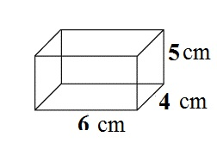

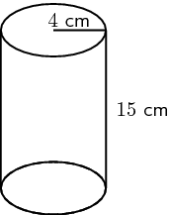

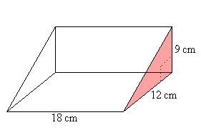

2. Which of the following has a larger volume? By how much is the volume larger?

3. Using the digits 1 through 9, at most one time each, place a digit in each box to create two rectangular prisms where the larger one has double the volume of the other.

4. What is the greatest volume you can make with a rectangular prism that has a surface area of 20 square units? (hint – you need to find dimensions that will give you a surface area of 20 square units and then find the volume)

