1) Find the area of a square with each side length.

a) 7 units b) 11 units

2) Show that 16 is a square number.   
Use a diagram, symbols, and words.

3) Which of these numbers is a perfect square?  
How do you know?

a) 14 b) 60 c) 36

4) These numbers are not square numbers.   
Which two consecutive square numbers is each number between?

a) 7 b) 30 c) 50 d) 90

**5**) A square patio has area 225 m2.

a) Find the dimensions of the patio.

b) The owner wants to put lights around the patio.   
How many metres of lighting is needed?

c)Each string of lights is 25 m long.   
 How many strings of lights are needed?

6) Find.

a) 62 b) 112 c) 52

7) Find a square root of each number.

a) 49 b) 64 c) 196

8) a) List the factors of each number in ascending order.   
Which numbers are squares? How do you know?

i) 36 ii) 88

9) The factors of each number are listed in ascending order.   
Which numbers are square numbers?   
Find a square root of each square number.

a) 216: 1, 2, 3, 4, 6, 8, 9, 12, 18, 24, 27, 36, 54, 72, 108, 216

b) 196: 1, 2, 4, 7, 14, 28, 49, 98, 196

c) 441: 1, 3, 9, 21, 49, 147, 441

10) Find a number whose square root is 24.

11) Use number lines to estimate the following square roots:

a)  b) 

c)  d) 

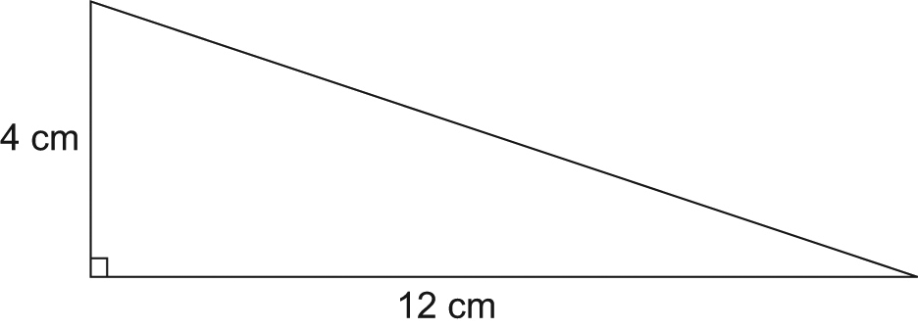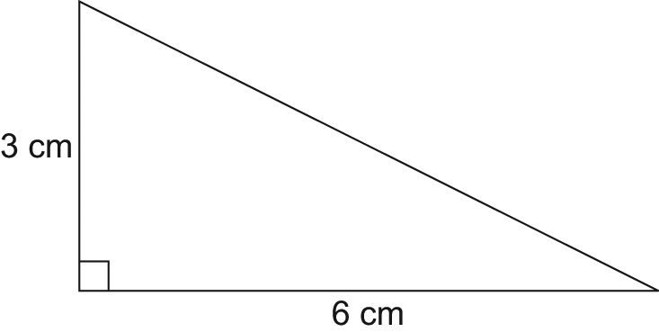12) Find the length of the unmarked side in each right triangle.   
Give your answers to one decimal place.

**a) b)**

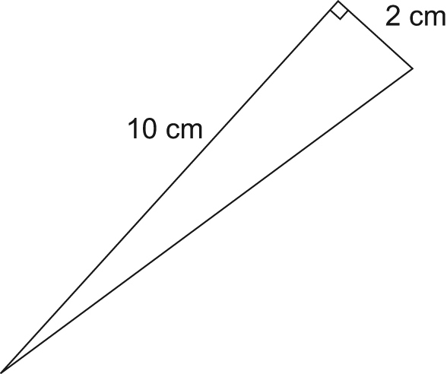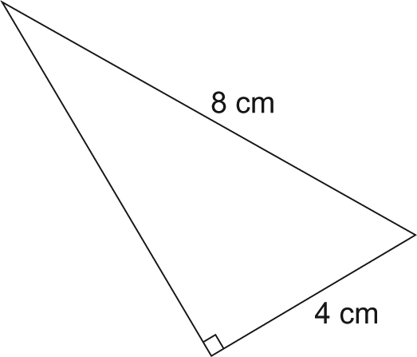

**c) d)**

**13)** Each set of measurements below represents the side lengths of a triangle.  
Identify which triangles are right triangles.   
How do you know?

**a)** 3 cm, 4 cm, 6 cm

**b)** 7 m, 24 m, 25 m

**c)** 6 cm, 8 cm, 10 cm

**14)** Which sets of numbers below are Pythagorean triples?

**a)** 20, 21, 29 **b)** 11, 34, 35 **c)** 20, 101, 99 **d)** 30, 34, 16

**15)** Jovi is laying a foundation for a garage with dimensions 10 m by 6 m.  
To check that the foundation is square, Jovi measures a diagonal.   
How long should the diagonal be?   
Give your answer to one decimal place.

**16)** A guy wire is 14 m long. It is attached to a TV tower 12 m high.  
The guy wire is fastened to a stake in the ground.  
How far is the stake from the base of the TV tower?  
Give your answer to one decimal place.

**17)** Copy each square on grid paper. Find its area.  
Then write the side length of the square.

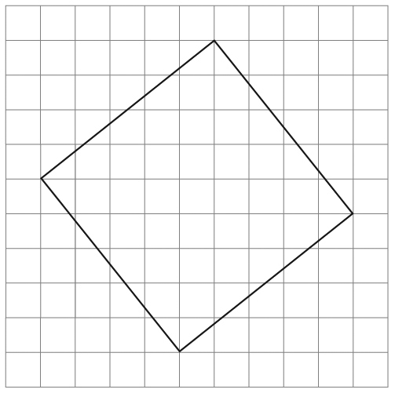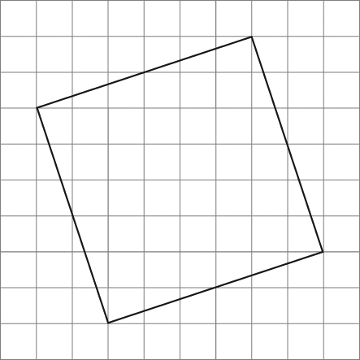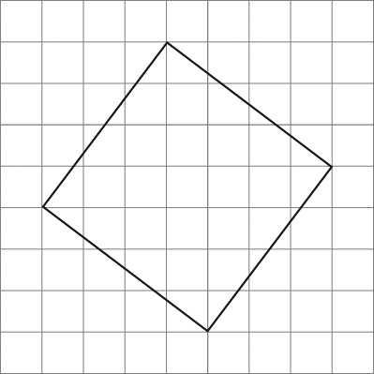a) b) c)