Percents Hand-In #1
Miss McKechnie

- NEATLY represent each percent on the 10 x 10 grids. Use one full grid to represent 100%.
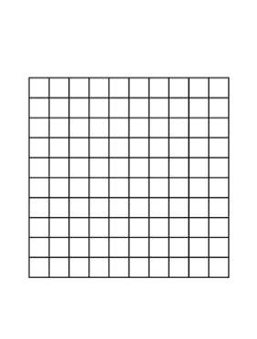
  - 175%

- Calculate each amount. Show your work using fraction form or decimal form (2 marks per question):

  - 83% of 80 = _____ c. 8% of 30 = _____

  - 210% of 11 = _____ d. 350% of 50 = _____

- Your friend wants you to help deliver newspapers that will sell for a total of $350. He gives you two choices, either 6% of total sales or a lump sum of $25.Which should you choose to make the most money? Prove it.

- Complete the table below

Percent | Fraction | Decimal
102%
 | $$\frac{7}{3}$$
 |  | 2.34
625%
 | 2$\frac{1}{3}$
 |  | 1.86

- 10 students in Cam’s class play in the local soccer league. They make up 5% of the league. How many students are in the league?

- Solve each problem. Round your answer to two decimal places.

  - What is 25% of 530?

  - 43 is 31% of what number?

  - What % of 69 is 55?

  - 140% of a number is 70

