**Unit 5: Geometry and Measurement**

|  |  |
| --- | --- |
|  |  |
|  | **Net** |

|  |  |
| --- | --- |
|  | **Cylinder** |
|  |  |

|  |  |
| --- | --- |
|  | **Right Rectangular Prism** |
|  |  |

|  |  |
| --- | --- |
|  | **Right Triangular Prism** |
|  |  |

|  |  |
| --- | --- |
|  | **Surface Area** |
|  |  |

|  |  |
| --- | --- |
|  | **Volume** |
|  |  |

**One-dimensional figures:**

* We can only measure their ____________________________
* Draw an example:

**Two-dimensional figures:**

* These figures have a ______________ and a ____________ .
* Draw an example:

**Three-dimensional figures:**

* These figures have _______________, _______________, and __________________ .
* 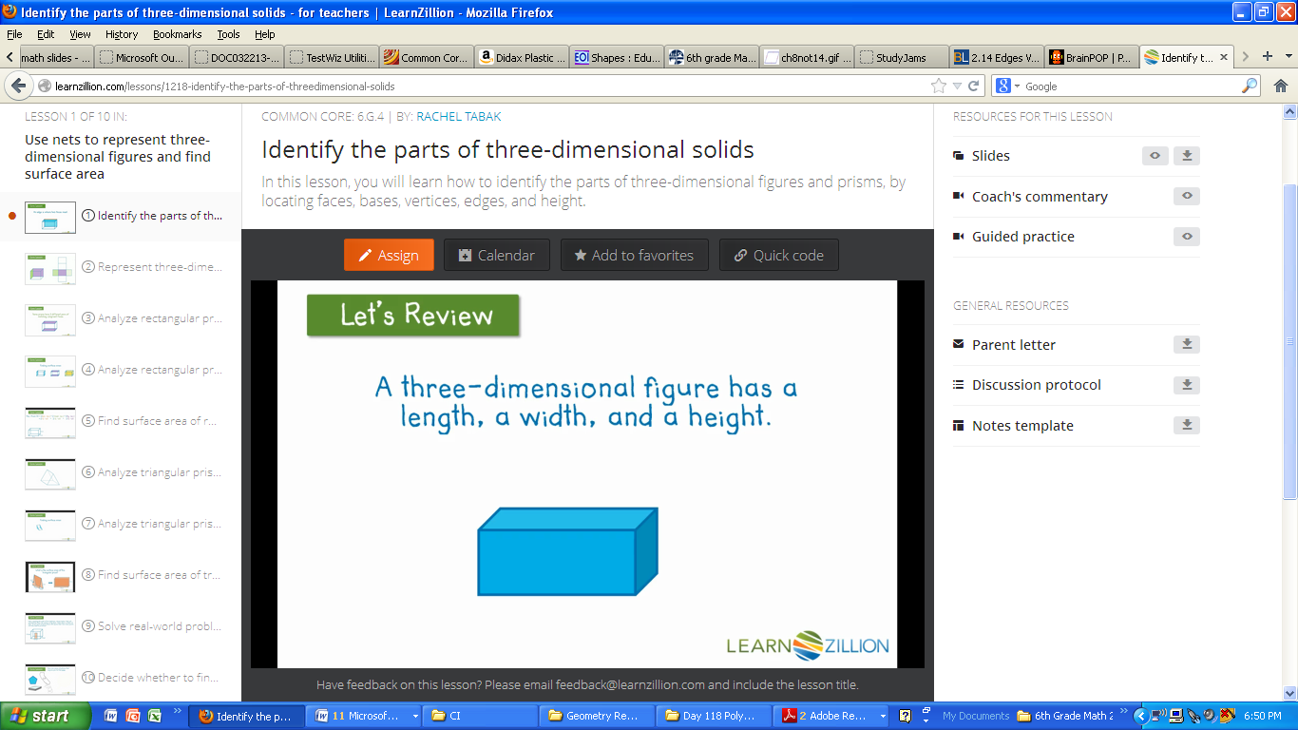Example:

**Face:**

* A face is any __________ surfaces on a three-dimensional figure.
* 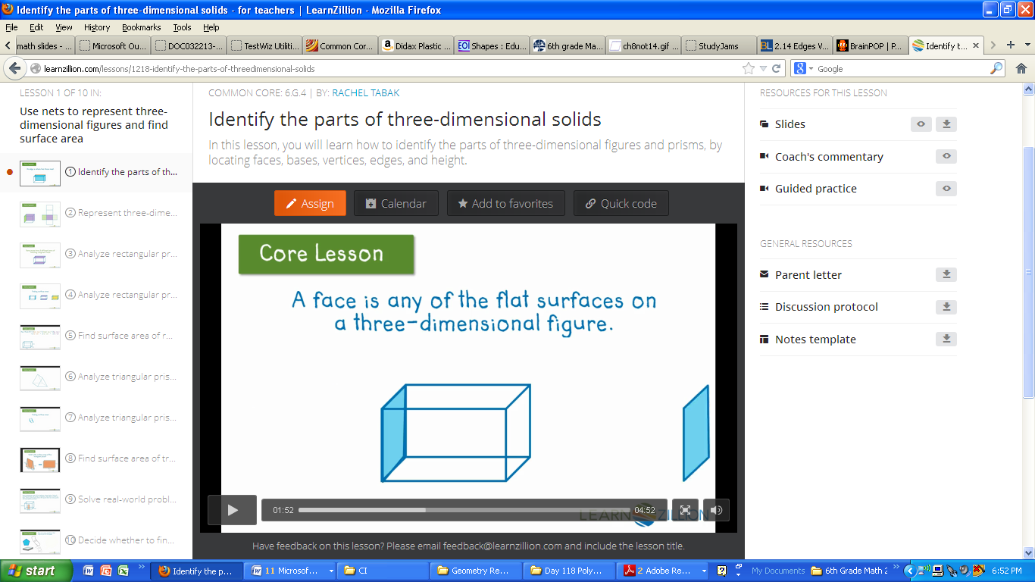Example:
* This 3-D figure has _____ faces.

**Edge:**

* An edge is where 2 faces _____________ .
* 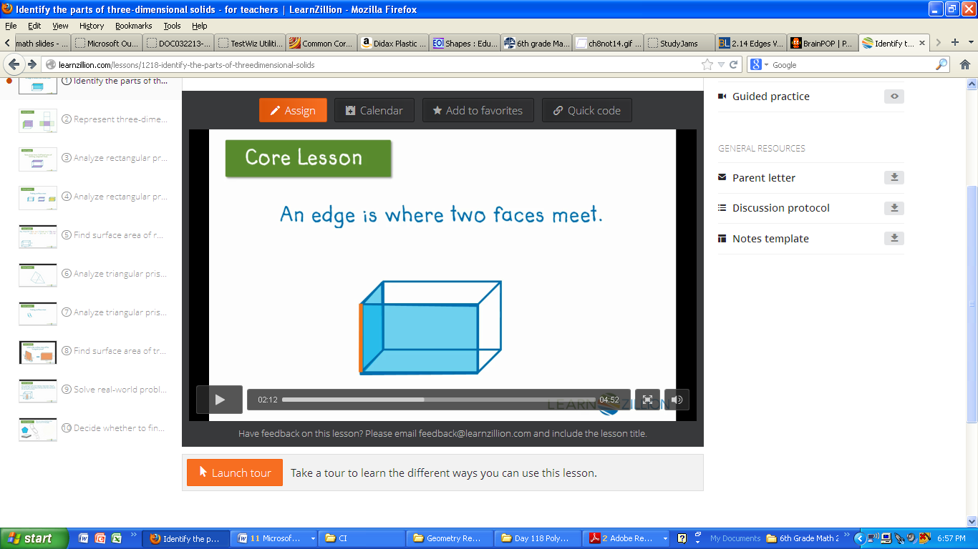Example:

**Vertex:**

* A vertex is a point where ______ edges meet.
* The plural of vertex is ______________ .
* 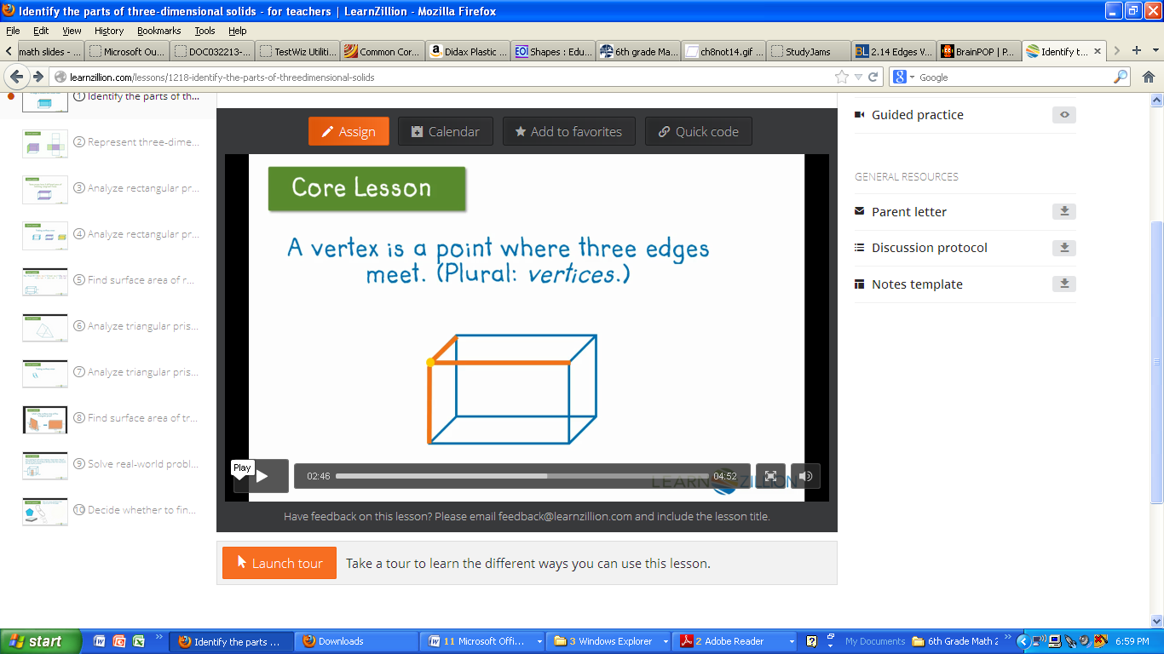Example:

**Prism:**

* A prism is a three-dimensional figure with ______ parallel and _________________ polygonal bases.
* 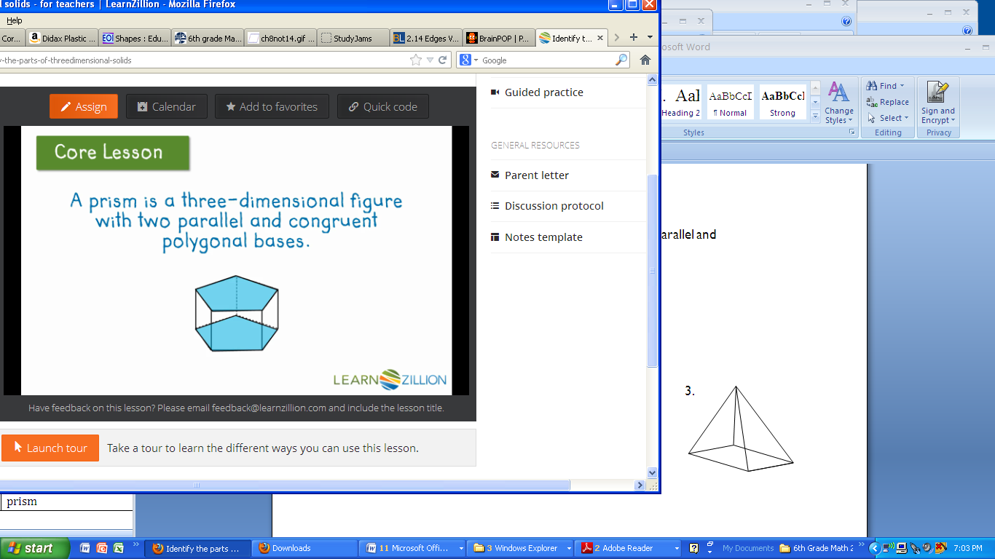Example: This is a pentagonal prism

**Pyramid:**

* A pyramid is not a prism because it has only 1 base.
* 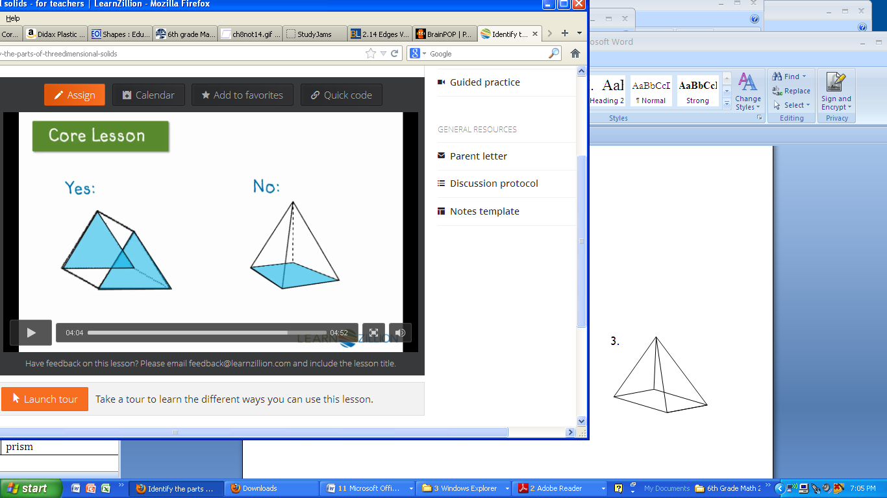Example:

**Height:**

* The distance between a prism’s bases.
* The height is perpendicular to the ______________ .
* 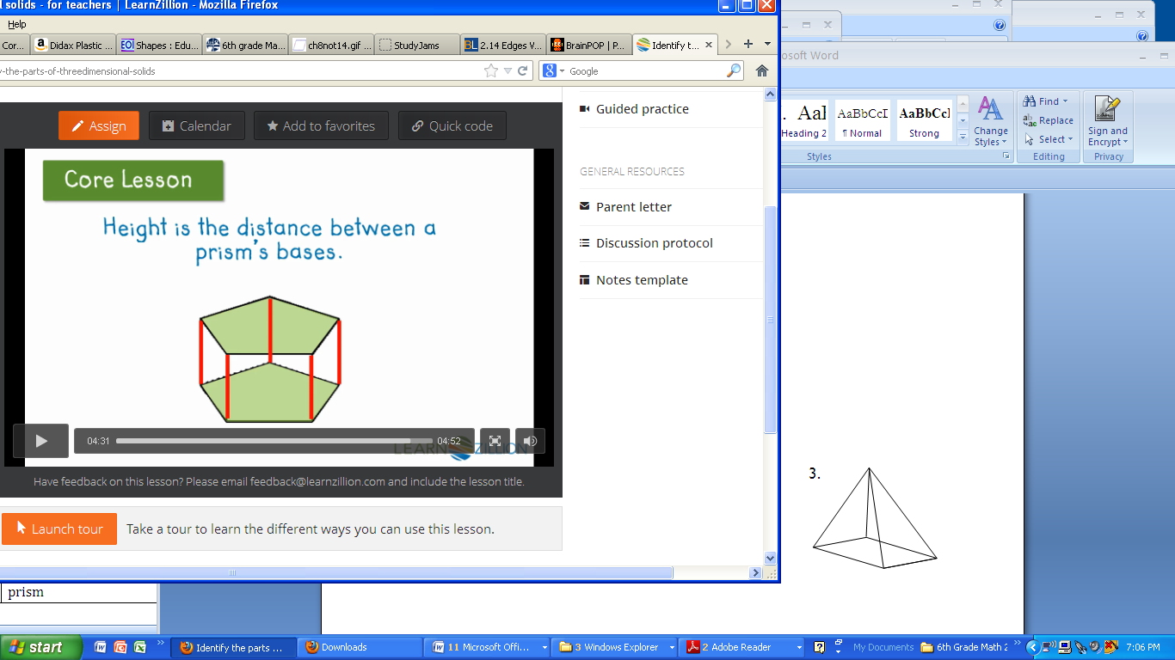Example:

Name the following 3D shapes. Match the 3D shape to its net.

Choose the net that represents each 3D shape.

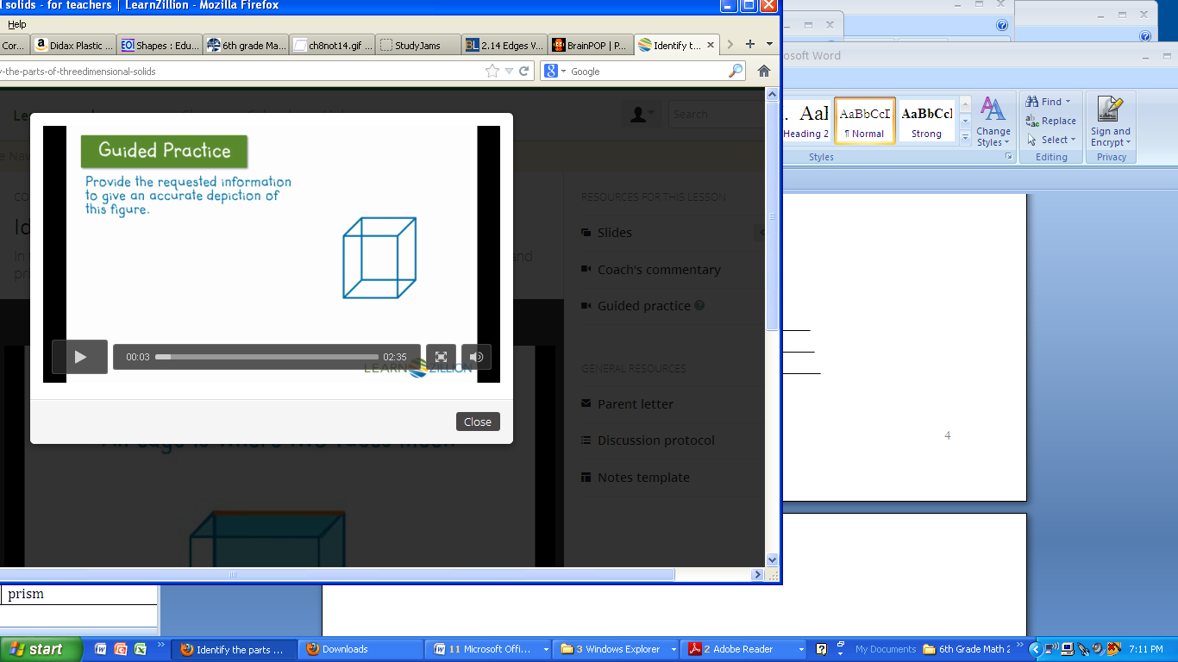

Use the figure to the right to answer these questions:

1. Is this a prism? ________
2. How many faces does it have? ___________________
3. How many edges does it have? ___________________
4. How many vertices does it have? __________________

Classifying Three-Dimensional Figures

**Directions:** work with your group with each figure. Use your “Naming Three-Dimensional Figures” sheet to figure out the name of each figure. Then fill in the number of faces, edges, and vertices.

|  |  |  |  |  |
| --- | --- | --- | --- | --- |
| **Name of 3D Figure:** | **# of faces:** | **# of edges:** | **# of vertices:** | **Is it a prism, pyramid or neither?** |
| 1 |  |  |  |  |
| 2 |  |  |  |  |
| 3 |  |  |  |  |
| 4 |  |  |  |  |
| 5 |  |  |  |  |
| 6 |  |  |  |  |
| 7 |  |  |  |  |
| 8 |  |  |  |  |
| 9 |  |  |  |  |

List the solids that are prisms:

Name: ____________________________

Faces: ____________________________

Name: ____________________________

Faces: ____________________________

Name: ____________________________

Faces: ____________________________

__________________________________________________

What makes the three-dimensional figures prisms?

________________________________________________________________

_________________________________________________________________

Review: Three-dimensional figures:

* These figures have _______________, _______________, and __________________ .

Net:

* A net is a two-dimensional ________________ of a three-dimensional figure that can be folded to form the figure.
* 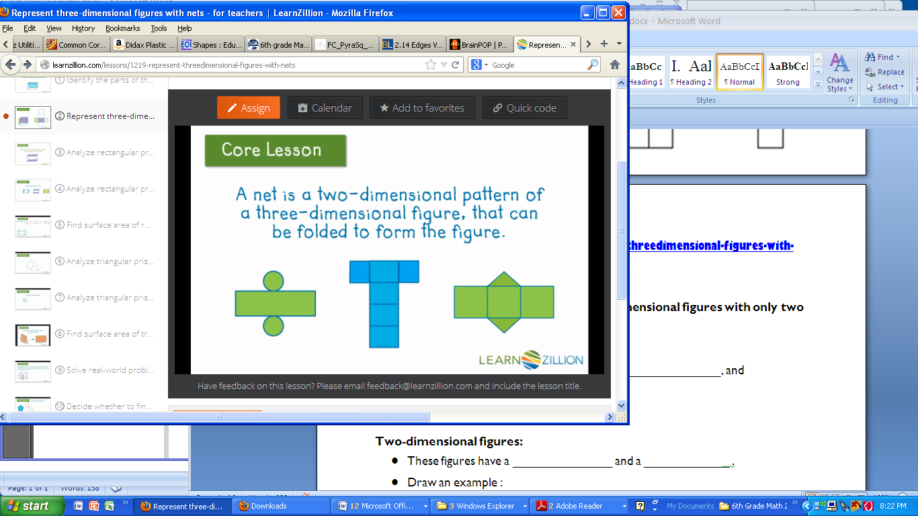Examples:

With this Net and Solid:

* 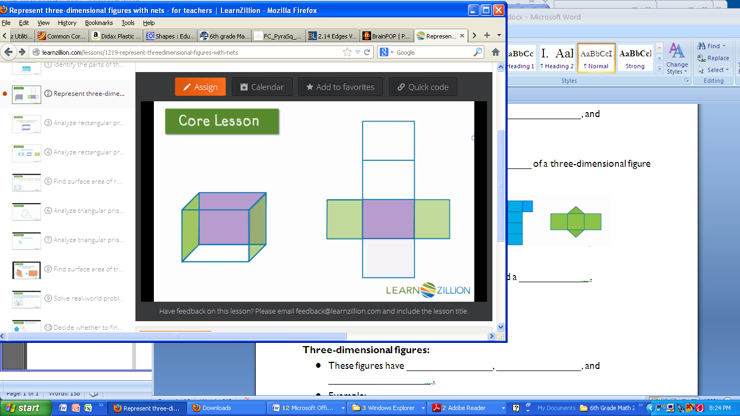_____ of the faces are purple
* ______ are green

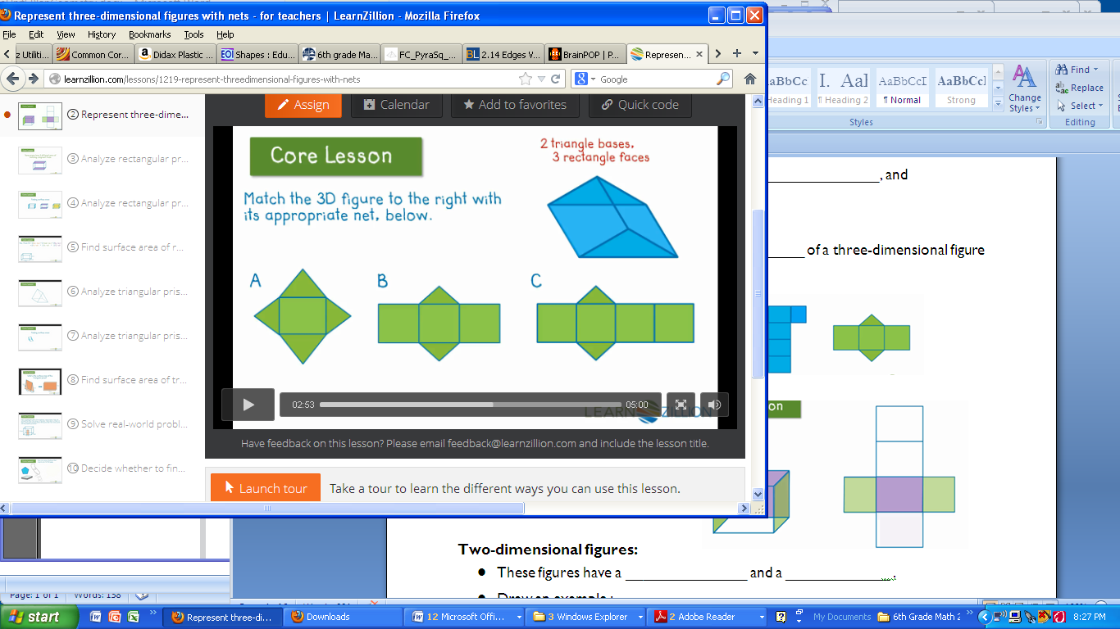Match the 3D figure with the appropriate net:

* This figure has _______ triangle bases and _______ rectangle faces.



**SET OF NETS**

* Predict the shape you think the net will fold into
* Shade the faces labeled “B”
* Cut out, fold, and construct each geometric shape
* Complete the table and answer the questions

|  |  |  |  |  |  |
| --- | --- | --- | --- | --- | --- |
| **Net #** | **Prediction of geometric shape** | **Shape of shaded faces** | **Shape of faces not shaded** | **Number of shaded faces** | **Specific geometric name of shape** |
| **1** |  |  |  |  |  |
| **2** |  |  |  |  |  |
| **3** |  |  |  |  |  |
| **4** |  |  |  |  |  |

1. Compare shapes 1 and 4.
2. Compare shapes 2 and 3.
3. Prisms have how many bases? What are the shapes of the faces?
4. Pyramids have how many bases? What are the shapes of the faces?
5. Draw a net of a triangular prism and a triangular pyramid.

**Surface Area of Rectangular Prisms**

Surface area is the _______ of the _______ of all the faces of a solid figure. A rectangular prism is a 3-dimensional __________ shape which has _____ faces that are _________. A net is a _______ dimensional representation of a _____- dimensional figure. You can use the nets to help you find ______________.

We can find the surface area of a rectangular prism by using a __________ to find the area of each face, and then adding them together.

Draw the net of the rectangular prism below. Then, find the surface area of the rectangular prism using the net :

|  |  |
| --- | --- |
| Side | Area |
| A |  |
| B |  |
| C |  |
| D |  |
| E |  |

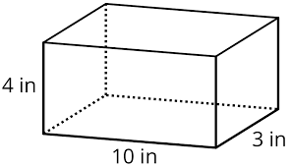

You can also use the formula _________________ to find area of a rectangular prism. The formula to find surface area of a cube is ____________________.

|  |  |
| --- | --- |
| Find the surface area of the figure below: | Find the surface area of the figure below: |
| Find the surface area of the figure below : | Find the surface area of the figure below |
| James is wrapping a birthday gift of his mom. The box has a length of 4 meters, a width of 3 meters, and a height of 1 foot. What is the exact amount of wrapping paper that he needs to cover the gift? | |

**Surface Area of Triangular Prism**

Surface are is the __________ of the ______________ of all of the faces of a 3D figure. A triangular prism is made of two congruent _________________ bases connected by three _____________ faces.

You can use the nets to help you find ____________________________ of triangular prisms.

To find the surface area, find the ____________ of each face. Then, _________ the areas together. To find the area of a triangle, use the formula :______________________________

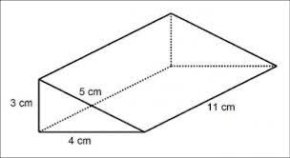Find the surface area of the triangular prism below :

|  |  |
| --- | --- |
| **Side** | **Area** |
| A |  |
| B |  |
| C |  |
| D |  |
| E |  |

Find the surface area of the triangular prism below :

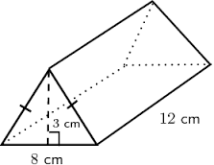

Find the surface area of the following triangular prisms

|  |  |
| --- | --- |
|  |  |
|  |  |

**Surface Area of Cylinder**

The surface area of a solid is the _________ of the ______of all its faces. To find the surface area of a cylinder, find the ___________ of each face. Then, ____________ the areas together.

To find the area of a circle, use the formula : _______________. To find the surface area of a cylinder, you can also use the formula :________________

Find the surface area of the cylinder below. Use 3.14 for π

|  |  |
| --- | --- |
| Side | Area |
| Base |  |
| Base |  |
| Lateral Side |  |

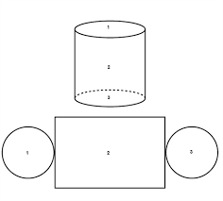

Find the surface area of the cylinder below. Use 3.14 for π.

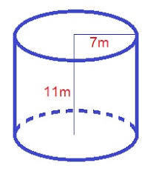

|  |  |
| --- | --- |
| Find the surface area of the cylinder below. Use 3.14 for π. Round your answer to the nearest tenth. | The base of a bucket of paint has a radius of 5 cm. The bucket has a height of 10m. Find the surface are of the bucket. Use 3.14 for π. Round your answer to the nearest tenth. |
| Find the surface area of the cylinder below. Use 3.14 for π. Round your answer to the nearest tenth. | A can of tuna is 3cm tall. The base has a radius of 7cm. Find the surface area of the can. Use 3.14 for π. Round your answer to the nearest tenth. |

**Volume of Right Rectangular Prisms**

The ______________ of a three-dimensional figure is a measure of the amount of space it occupies. Volume is measured in _______ units. A __________ cube is a cube with an edge of length of one unit.

**Cube**

**Rectangular Prism**

The volume of a rectangular prism is product of the length, ___________, and height. The formula for volume of a rectangular prism is _____________________. The formula for volume of a cube is _____________________________.

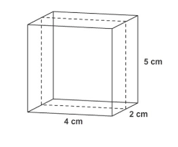Find the volume of each prism

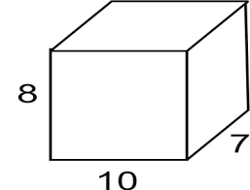

|  |  |
| --- | --- |
| **Side** |  |
| Area of One Side |  |
| Height |  |
| Volume of Shape |  |

|  |  |
| --- | --- |
| **Side** |  |
| Area of One Side |  |
| Height |  |
| Volume of Shape |  |

Find the volume of each rectangular prism

|  |  |
| --- | --- |
|  |  |
|  |  |
| An in-ground pool is 20 meters deep, 10 meters long, and 6 meters wide. How much water can this pool hold? Draw a picture and solve. | |

**Volume of Right Triangular Prism**

The ______________ of a three-dimensional figure is a measure of the amount of space it occupies. Volume is measured in _______ units. The volume of a triangular prism is product of the base and ______ divided by ______. The formula for volume of a triangular prism is _____________________. A right triangular prism must have a __________ angle in it.

|  |  |
| --- | --- |
| Side |  |
| Base |  |
| Height |  |

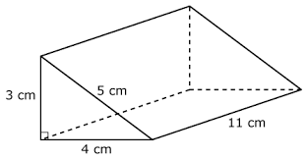

Find the volume of the following right triangular prisms

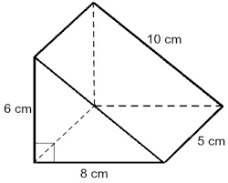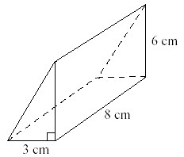

Find the volume of each triangular prism

|  |  |
| --- | --- |
|  |  |
|  | One mouse needs 20cm³of room in a tent. A tent with a height of 10cm, a length of 60cm and a width of 12cm is found by a family of 7 mice. Can they live in this tent comfortably? Draw a picture and solve. |

**Volume of Cylinder**

The ______________ of a three-dimensional figure is a measure of the amount of space it occupies. Volume is measured in _______ units. The volume of a cylinder is product of π, ___________, and height. The formula for volume of a cylinder is _____________________. The mathematical symbol, π, is equal to _________.

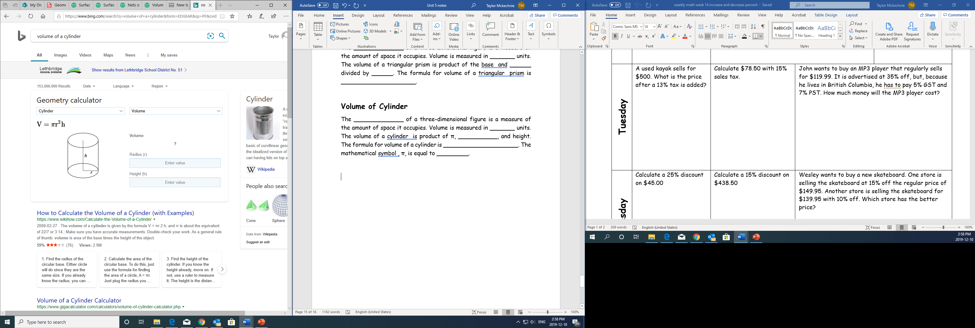

Find the volume of the following cylinder

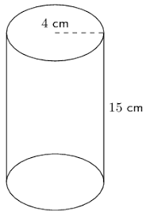

|  |  |
| --- | --- |
|  |  |
| Radius |  |
| Height |  |
| Π |  |
| Volume of Cylinder |  |

|  |  |
| --- | --- |
|  |  |
|  |  |
| Mr. Dersch was painting his fence. He needed 130cm $³$ of paint. The paint can was 10cm tall with a radius of 2cm. Would the paint can be big enough to hold 130cm $³$ of paint? Draw a picture of the cylinder and solve. | |

Find the volume of each cylinder